
Course End Project 1
Sales Dashboard in Excel
Akansha Chowdhury |  | Date- 29th July 2025

Business Analytics with Excel Certification Training
Designing a Sales Dashboard in Excel
The below are the following steps taken to make the dashboard-
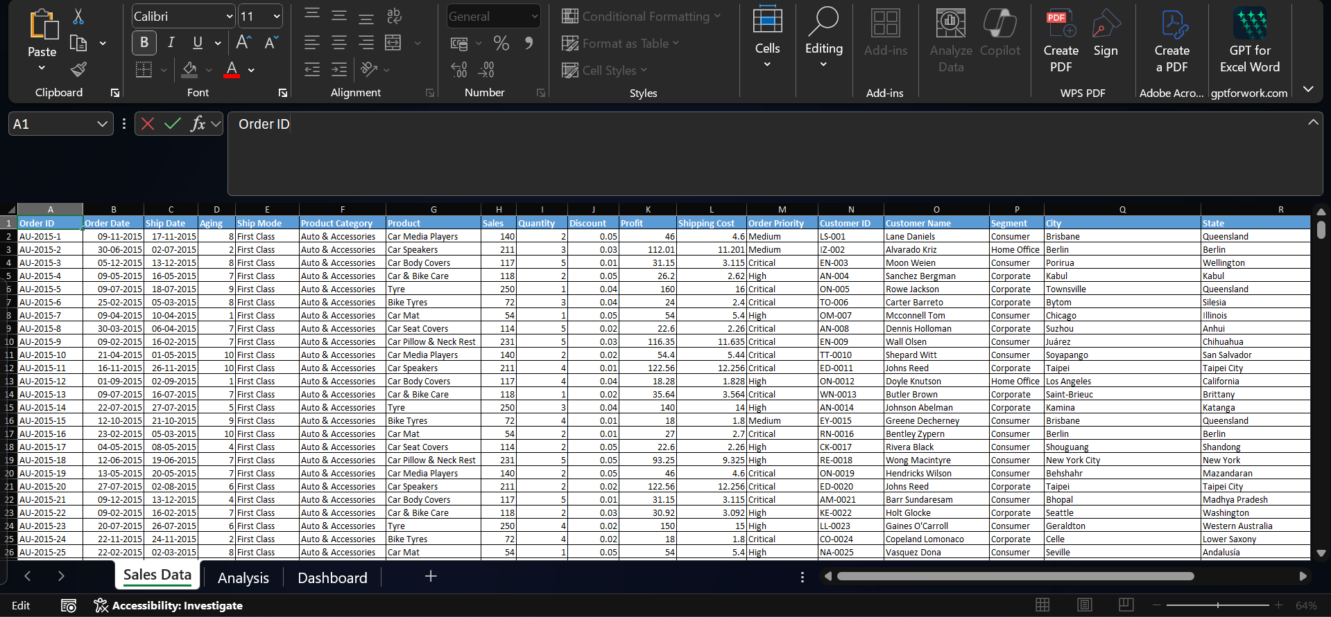
Step 1

The main data was collected and added to the sheet name Sales Data.
The other two sheet represents the –
- Analysis- This sheet contains the required tables and data to make the data.
- Dashboard – This sheet shows the dashboard.

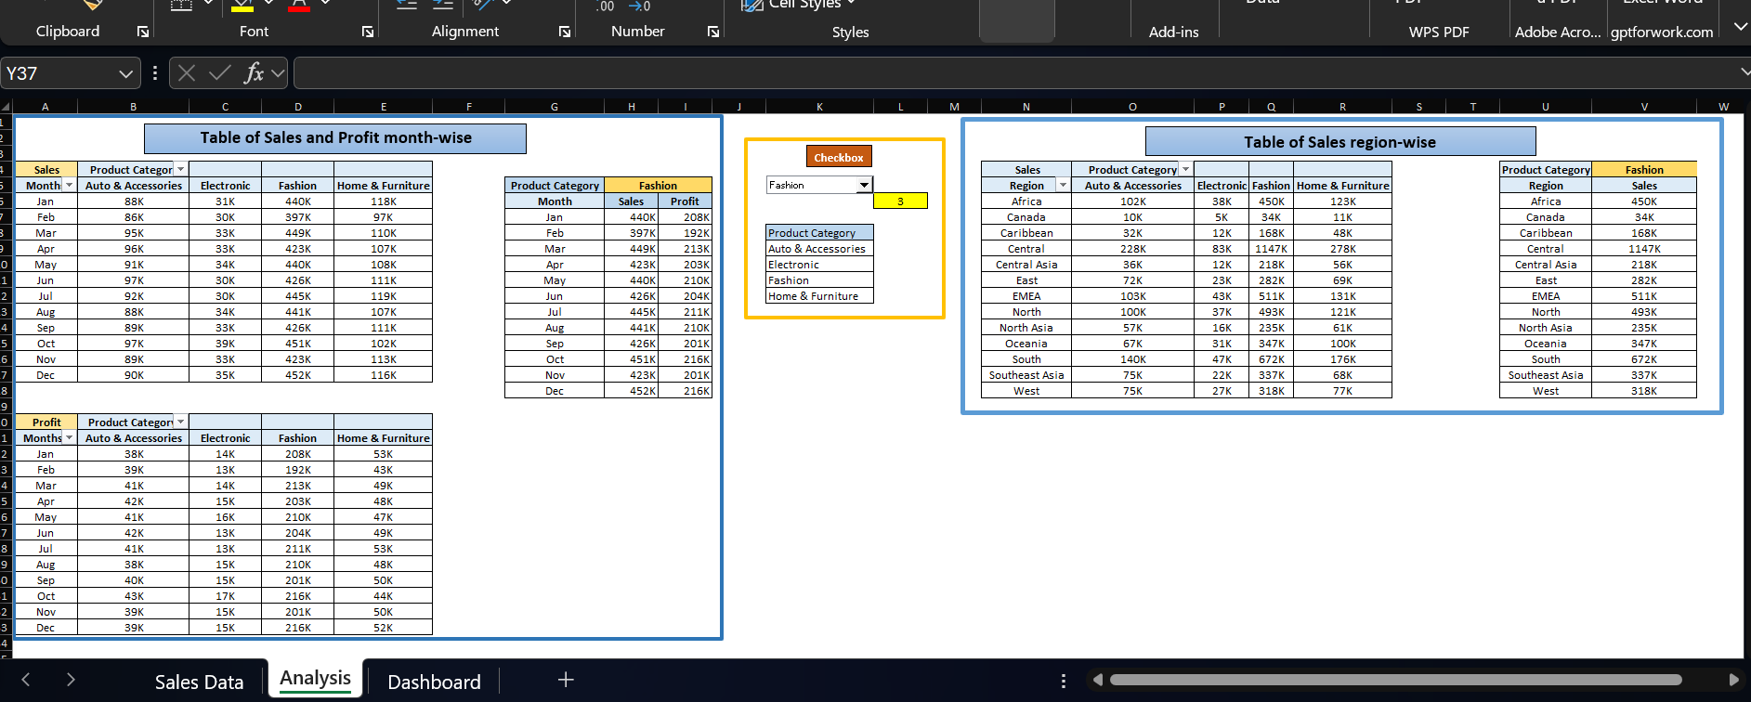
Step 2

Here the three different tables were taken using Pivot table function as mentioned –
- Table of Sales and Profit month-wise – here the sales and profit were separately taken for month-wise. Product Category was taken as column , month as row and sales and profit (respectively) as values.
- Table of Sales region-wise - Product Category was taken as column , month as row and sales as value.
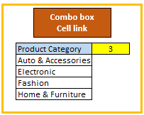
Step 3
User control Combo box was for the Product Categories (Auto & Accessories, Electronics, Fashion, Home & Furniture) which was taken from the Developer option -> Insert -> combo box.
It was added to the dashboard and the cell link was added to the analysis sheet .
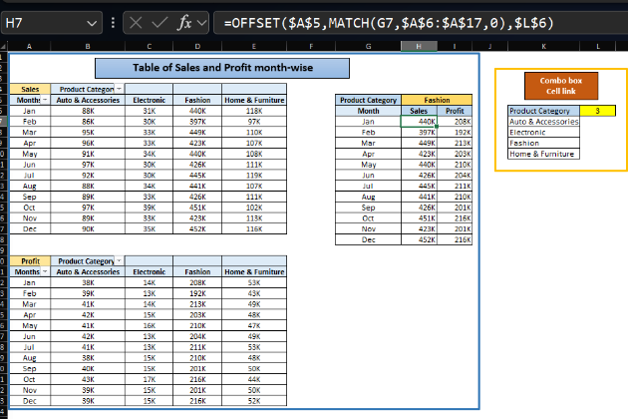
This was linked to all the three tables –
For the Table of sales and profit month-wise, to get the sales value the following code was used –
OFFSET($A$5,MATCH(G7,$A$6:$A$17,0),$L$6)
Two function was used OFFSET and MATCH to get the desired sales value for the selected product category.
The same formula was used to get product
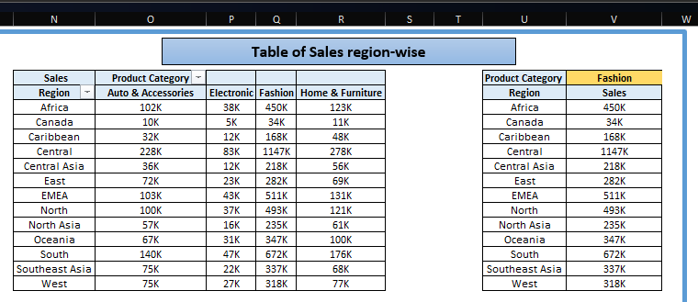
OFFSET($A$21,MATCH(G7,$A$22:$A$33,0),$L$6)
For the Table of sales region-wise, the formula used
OFFSET($N$5,MATCH(U6,$N$6:$N$18,0),$L$6)

Step 4
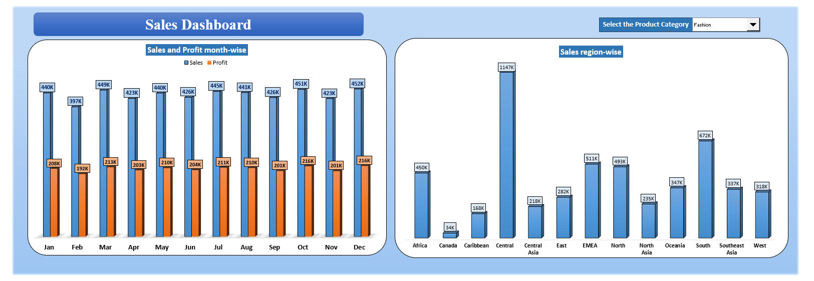
The bar plot of both the tables - Table of sales and profit month-wise and Table of sales region-wise were add to the dashboard along with the combo box –

These are the following steps taken to make the sales dashboard which shows the trend month-wise and product-wise accordingly to the selected Product Category.

